ELASTIC BLOCK STORAGE

TASK:

* Create three instances
* Connect ebs with two instances

WHAT IS EBS:

Amazon Elastic Block Store (Amazon EBS) provides scalable, high-performance block storage resources that can be used with Amazon Elastic Compute Cloud (Amazon EC2) instances. With Amazon Elastic Block Store, you can create and manage the following block storage resources.

EBS VOLUME:

These are storage volumes that you attach to Amazon EC2 instances. After you attach a volume to an instance, you can use it in the same way you would use a local hard drive attached to a computer, for example to store files or to install applications.

&#xA9; 2018, Amazon Web Services, Inc. or its affiliates. All rights reserved.
AWS block storage offerings
EC2
instance
store
sc1st1
io1gp2
EBS
SSD-backed
volumes
EBS
HDD-backed
volumes
HDDSSD
 

CREATION OF EC2:

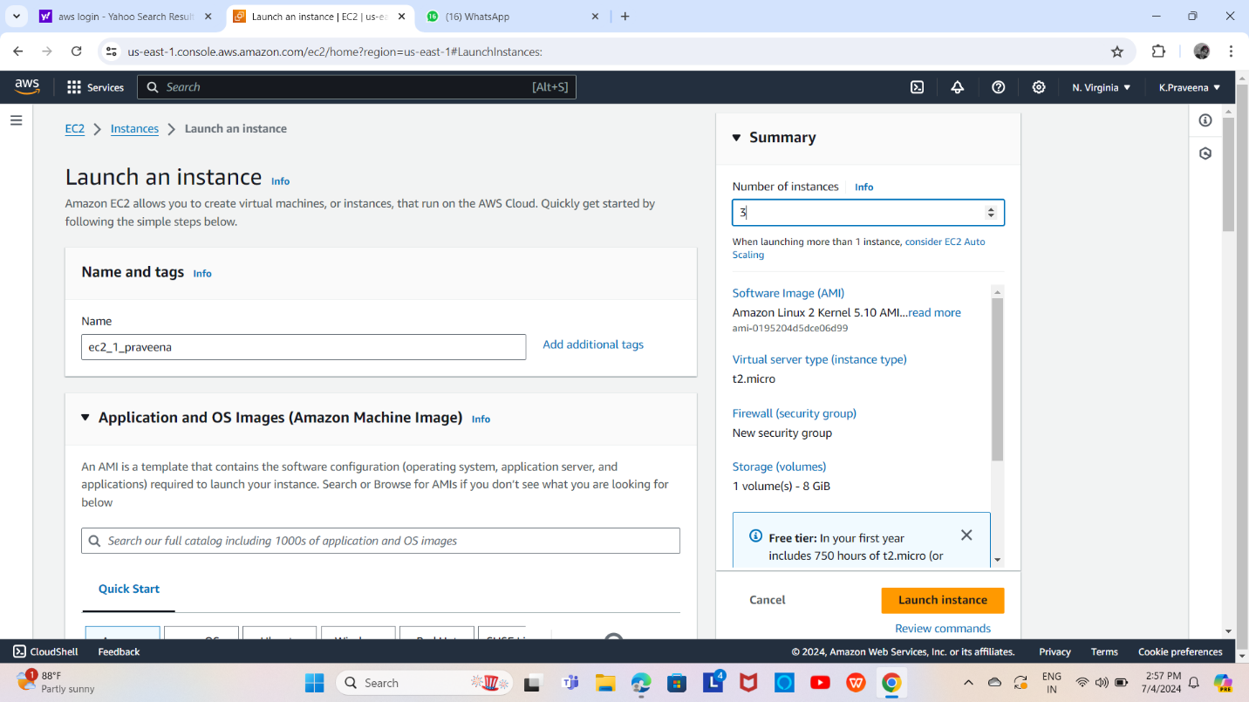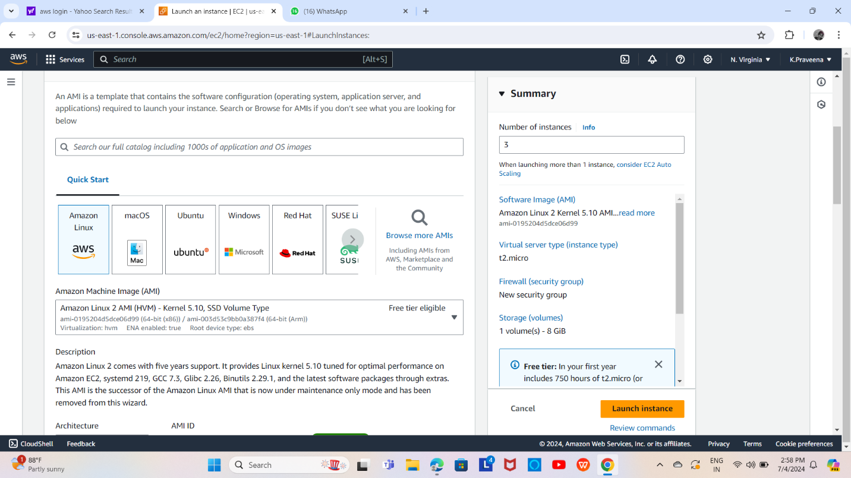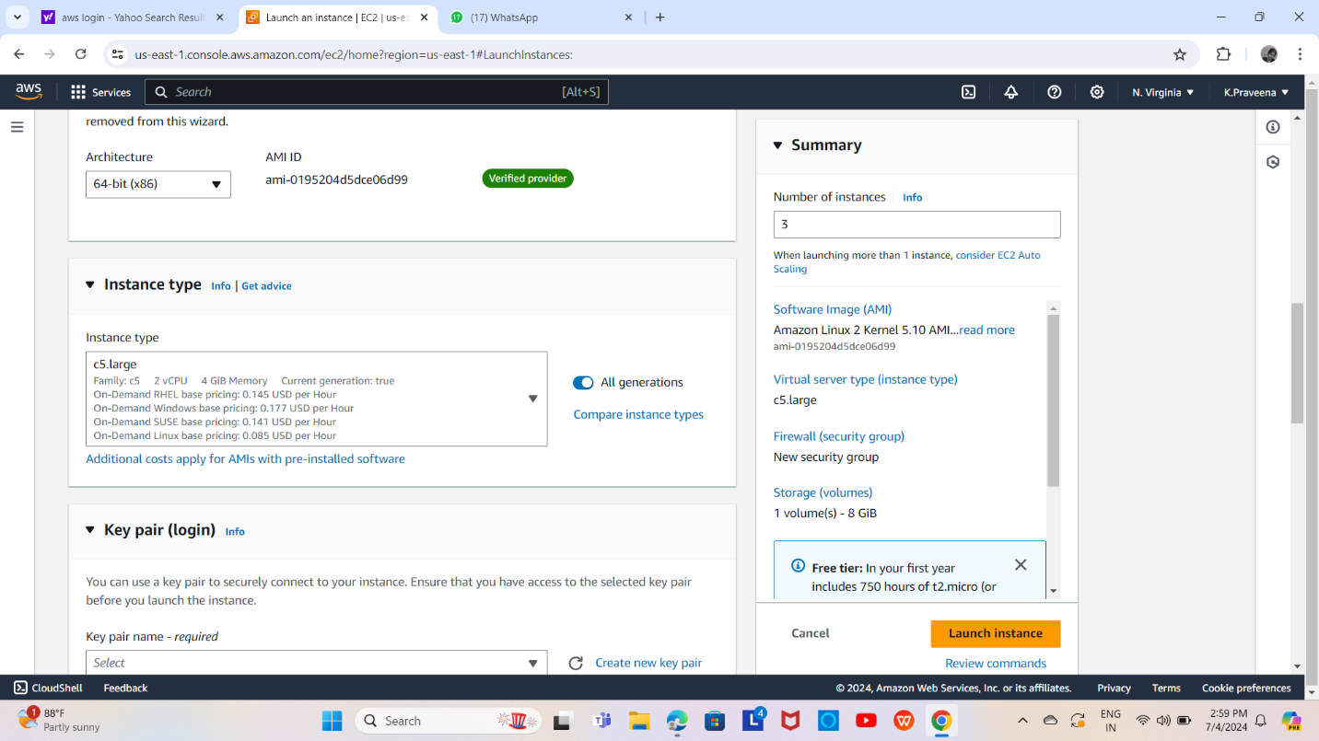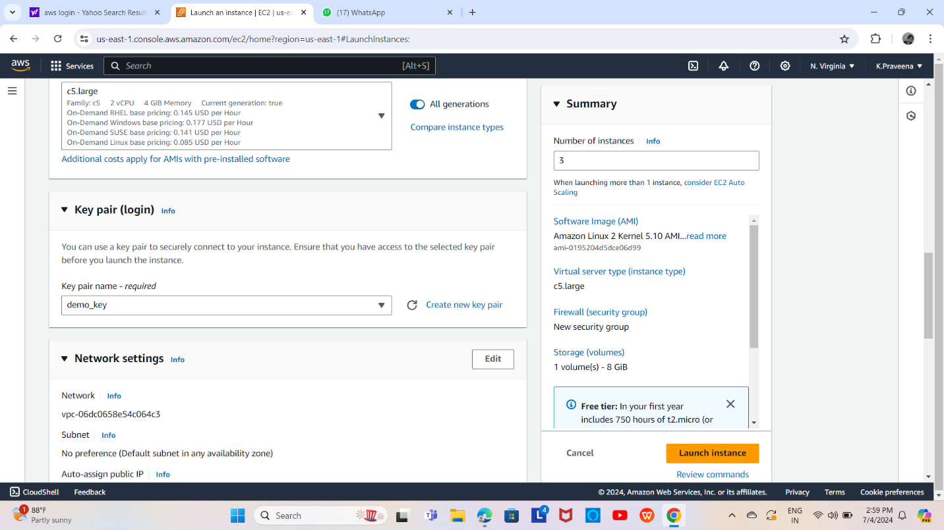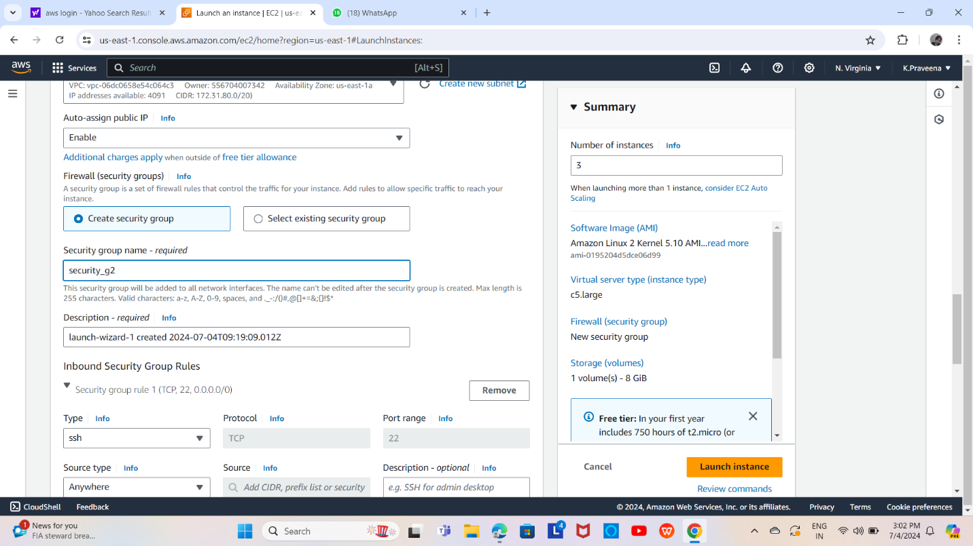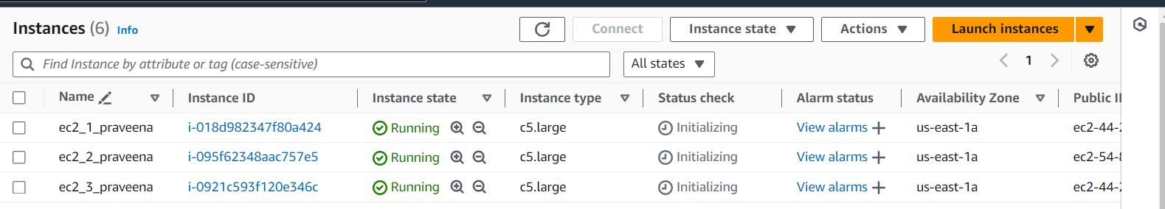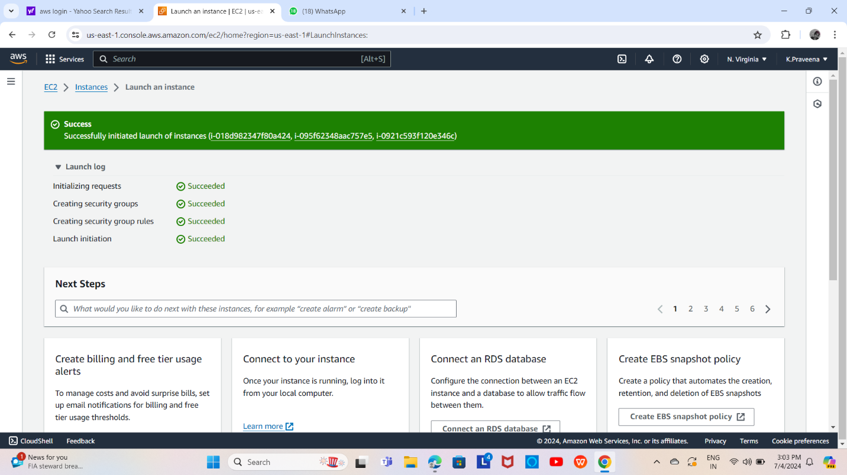

CREATION OF EBS VOLUME:

